* Brad Jones
* 4/12/2018
* Cisco Catalyst 2950

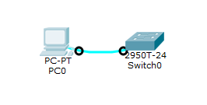

Questions:

* What does it take to connect a PC to a switch?
  + A physical connection. In this case a console cable.
  + A terminal or terminal emulator. In this case PuTTy
  + Permission. Security hasn’t been implemented on this switch, so were gtg.
* What do you see on the PC that indicates the connection to the switch was successful?
  + The terminal displays the prompt from the Cisco device. ( Switch> )
* How did the physical lab results differ from the PacketTracer lab with the same instructions?
  + There are many more commands available on the actual switch compared to the packet tracer